

Name: Abdulrahman Alawadhi
PRN: 25070122008
Branch: CSE
Subject: Programming with Java

ASSIGNMENT No.: 11

TITLE: Write a Java program to demonstrate the implementation of interfaces.

Problem Statement:

Write a Java program to demonstrate the implementation of interfaces.

Learning Objectives:

To implement interfaces for achieving abstraction and multiple inheritance of type.

Theory:

An interface specifies a set of abstract methods that implementing classes must define. It provides complete abstraction and supports multiple inheritance of type. Interfaces improve modularity, loose coupling, and software flexibility. They allow different classes to implement common behavior
while maintaining independent implementations. Interfaces are widely used in enterprise application development.

Outcomes:

Interfaces were successfully created and implemented across multiple, unrelated classes, with each class providing its own implementation of the same abstract method(s), as verified through the sample programs.

Input:
interface Drawable{ void draw();

double PI = 3.14159;
}

class Square implements Drawable{ double side;

Square(double s){ this.side = s;
}

public void draw(){
System.out.println("Drawing a Sqaure with side " + side);
}
}

class Circle implements Drawable{ double radius;

Circle(double r){ this.radius = r;
}

public void draw(){
System.out.println("Drawing a Circle with radius " + radius);
System.out.println("Area using interface contstant PI: " + (PI * radius * radius));
}
}

public class JAVA_EXP_11{
public static void main(String [] args){

Drawable shape1 = new Square(5); shape1.draw();

System.out.println();

Drawable shape2 = new Circle(4); shape2.draw();
}

}
Output:
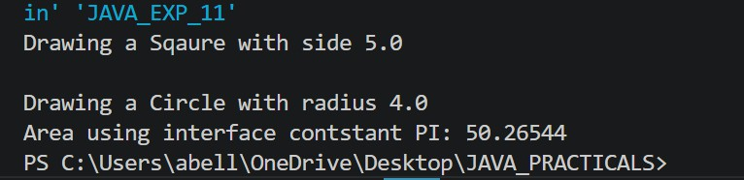

Conclusion:

Interfaces provide full abstraction by defining a contract of methods without any implementation, letting unrelated classes commit to the same behaviour in their own way. They enable a form of multiple inheritance of type in Java, promote loose coupling between components, and are widely used to design flexible, modular systems where implementations can vary independently of the interface itself.

Exercise:

- Create an interface Printable and implement it in Student and Employee classes.

Input:

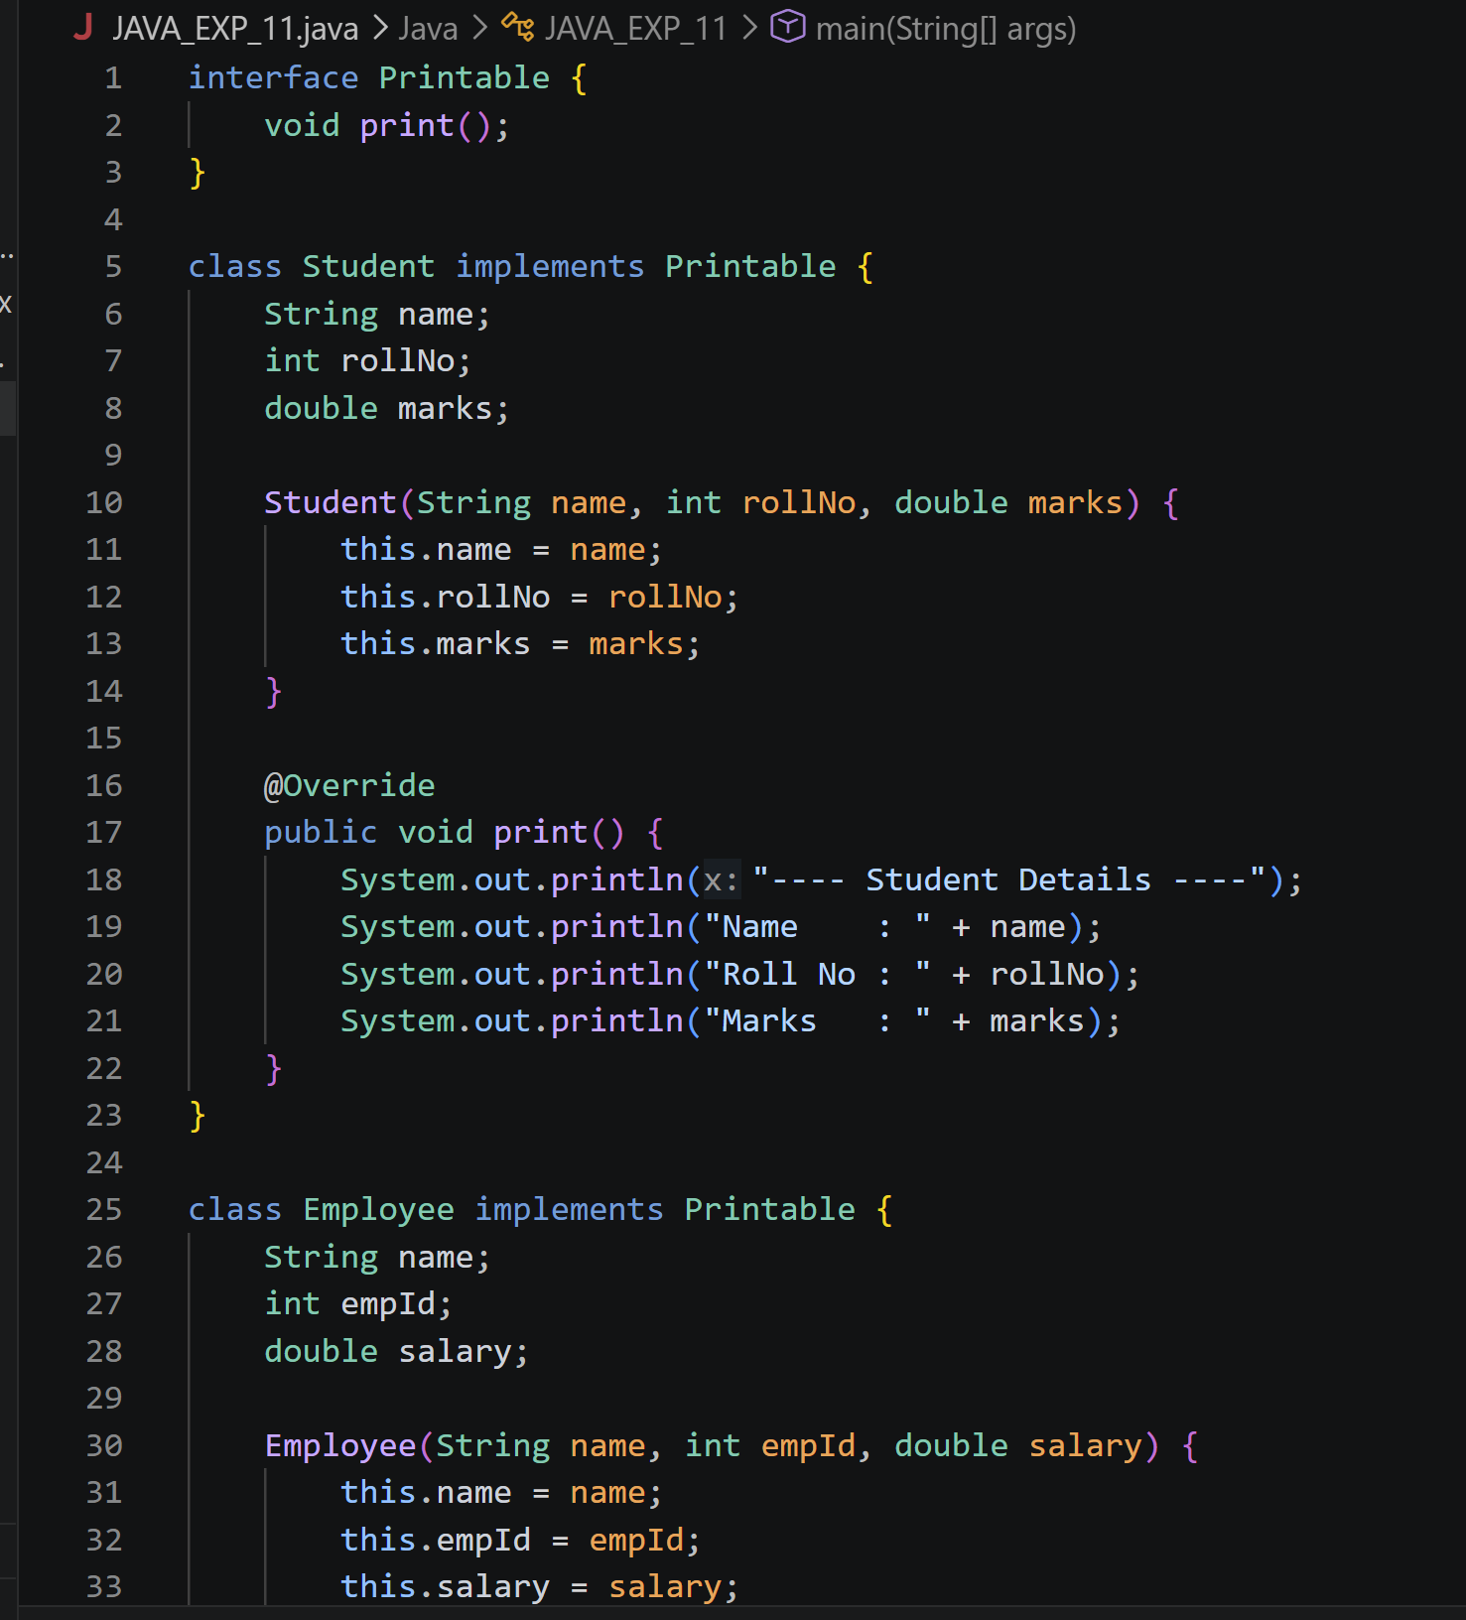

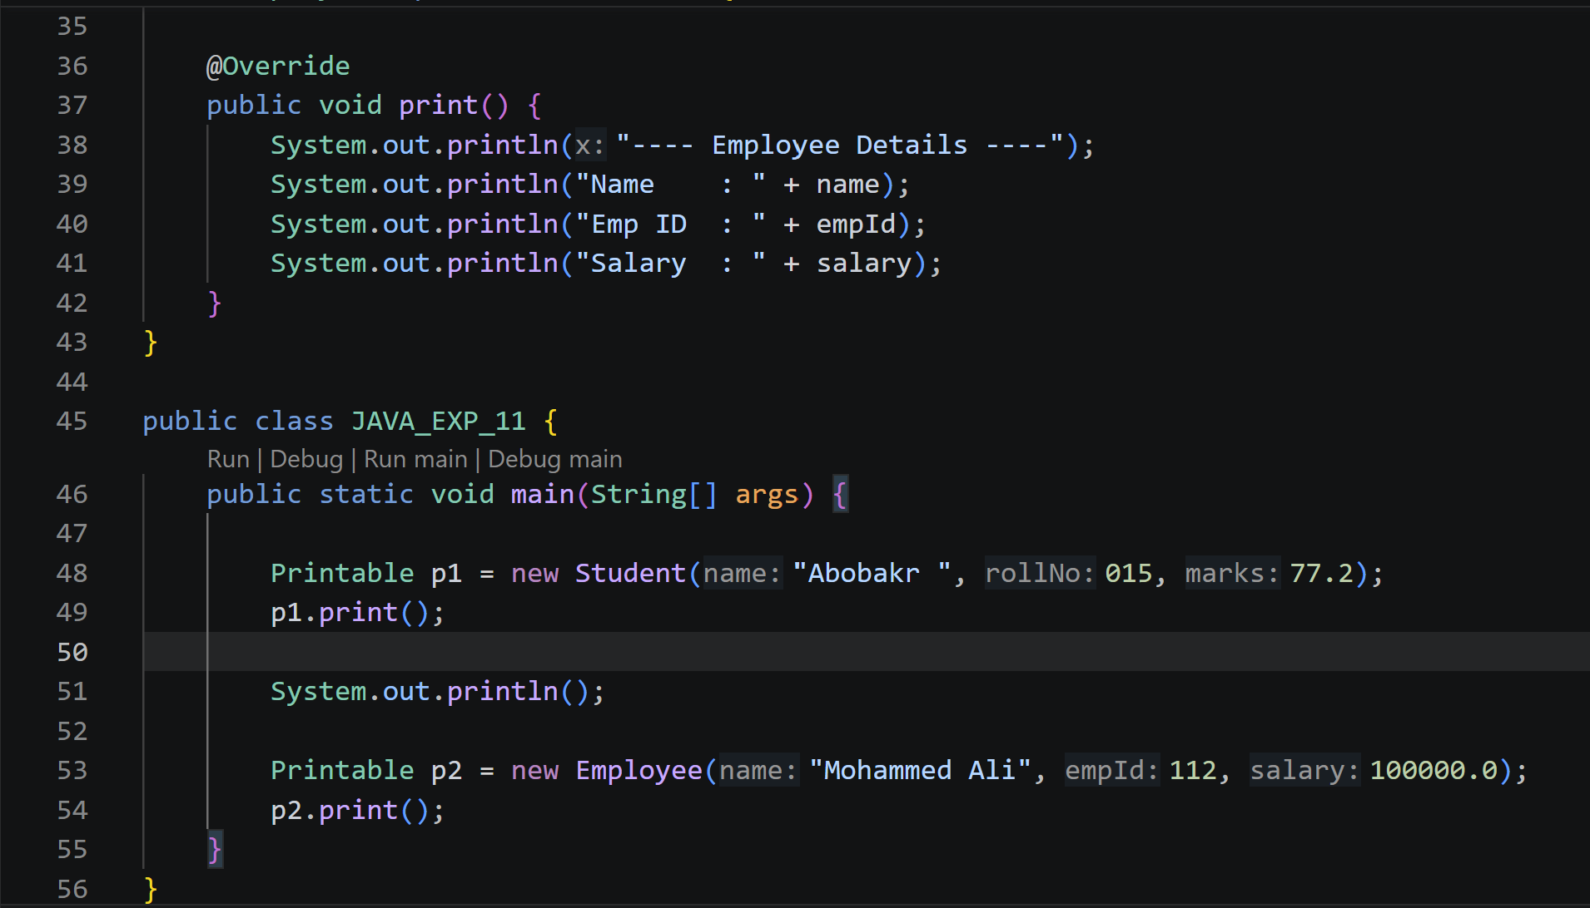
Output:
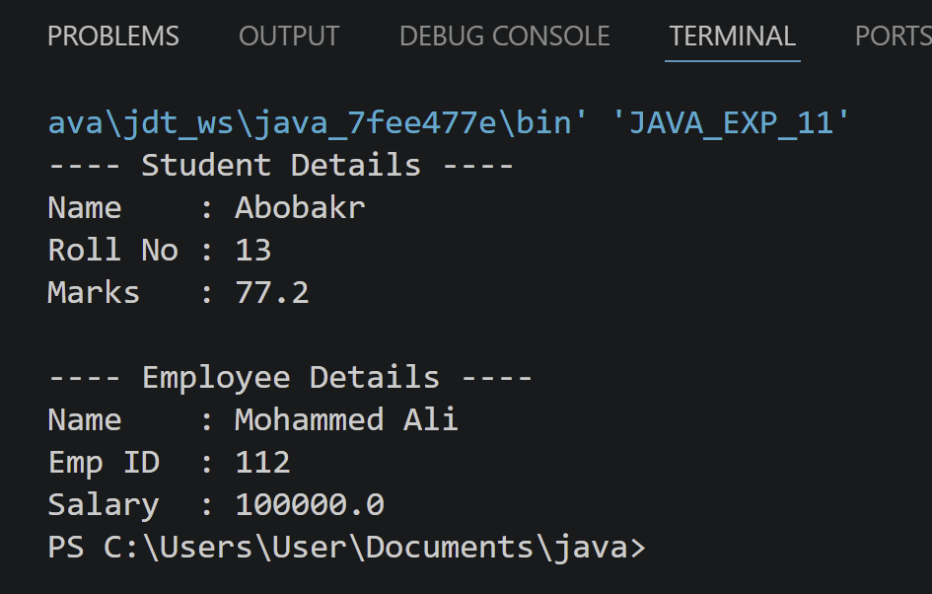

- Create an interface Switchable with a method turnOn(). Implement the interface in Light and Fan classes to display the device status.

interface Switchable { void turnOn();
}

class Light implements Switchable { String location;

Light(String location) { this.location = location;
}

@Override
public void turnOn() {
System.out.println("Light in " + location + " is now ON");
}
}

class Fan implements Switchable { int speed;

Fan(int speed) { this.speed = speed;
}

@Override
public void turnOn() {
System.out.println("Fan is now ON, running at speed level " + speed);
}
}

public class JAVA_EXP_11 {
public static void main(String[] args) { Switchable device1 = new Light("Living Room"); device1.turnOn();

Switchable device2 = new Fan(3); device2.turnOn();
}
}
